TopoDroid Data Export for Tunnel Drawing

After surveying with TopoDroid it's not immediately obvious how/which formats to upload. Please follow these instructions to give a correct centreline and aligned sketch that can then be put into Tunnel

—-----------------------

Survey Data

- From your survey in TopoDroid go to survey info

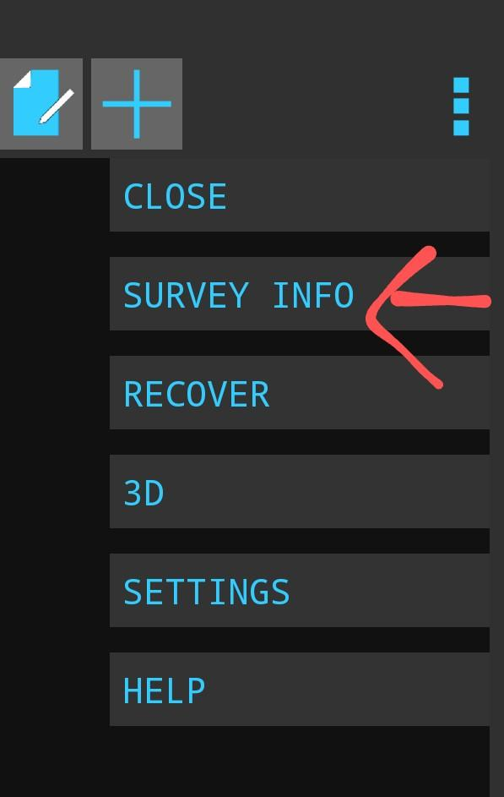

- Go to export

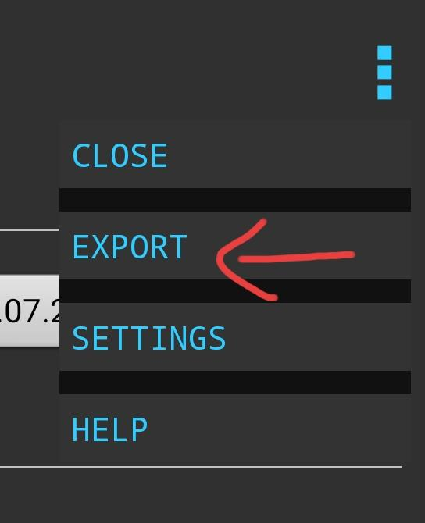

- Select survex

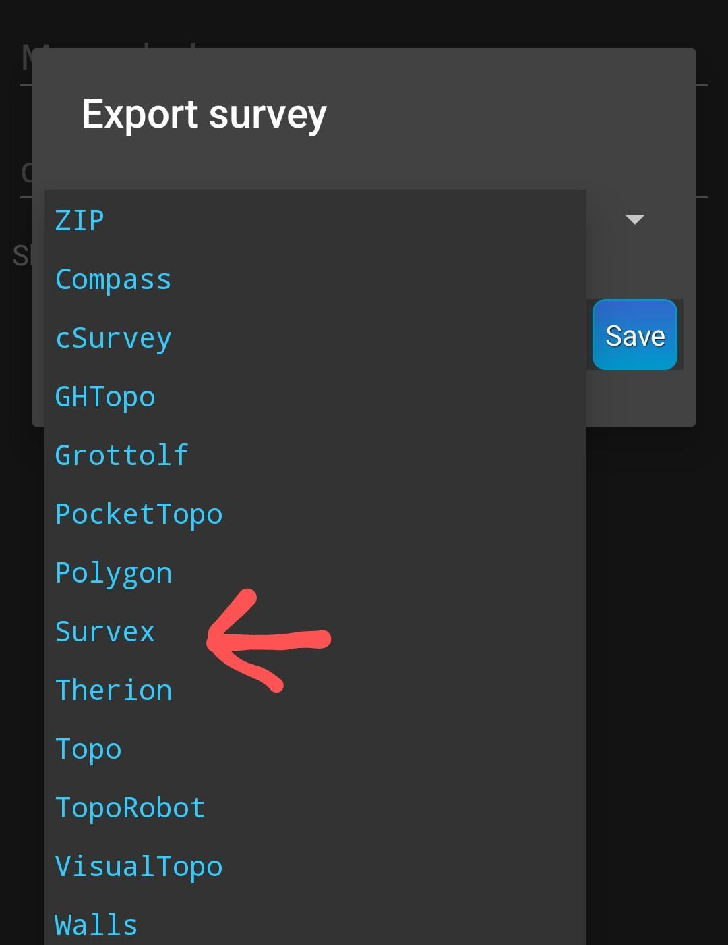

- Then save

—----------------------

Sketches

For each individual section (plan and elevation for each are automatically exported together)

- Select your sketch (plan or elevation)

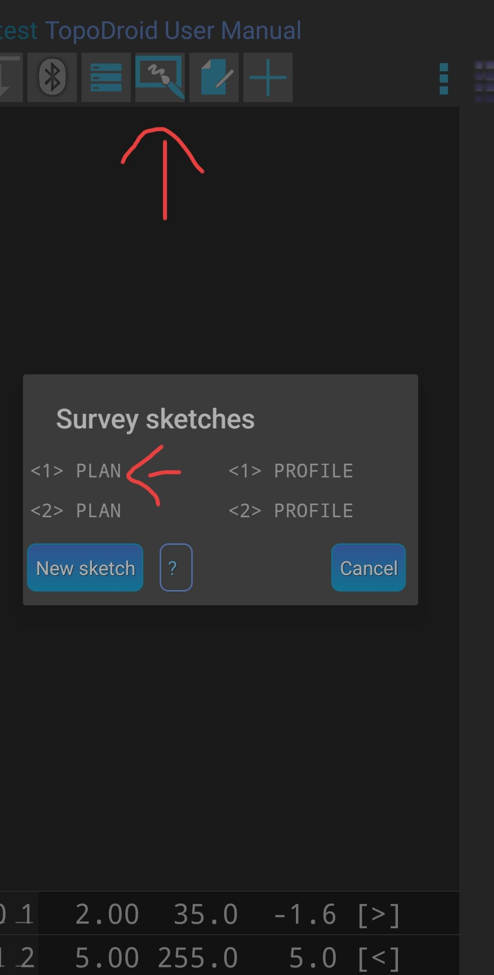

- Select export

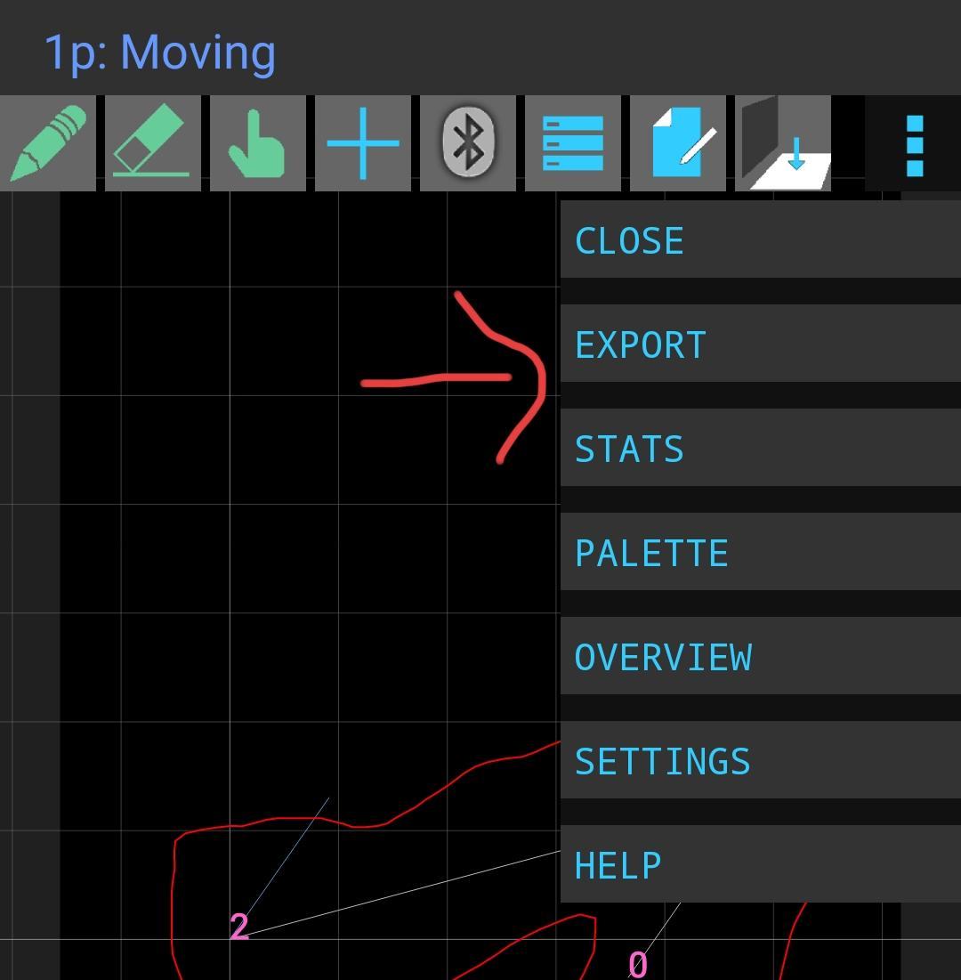

- Select SVG and save

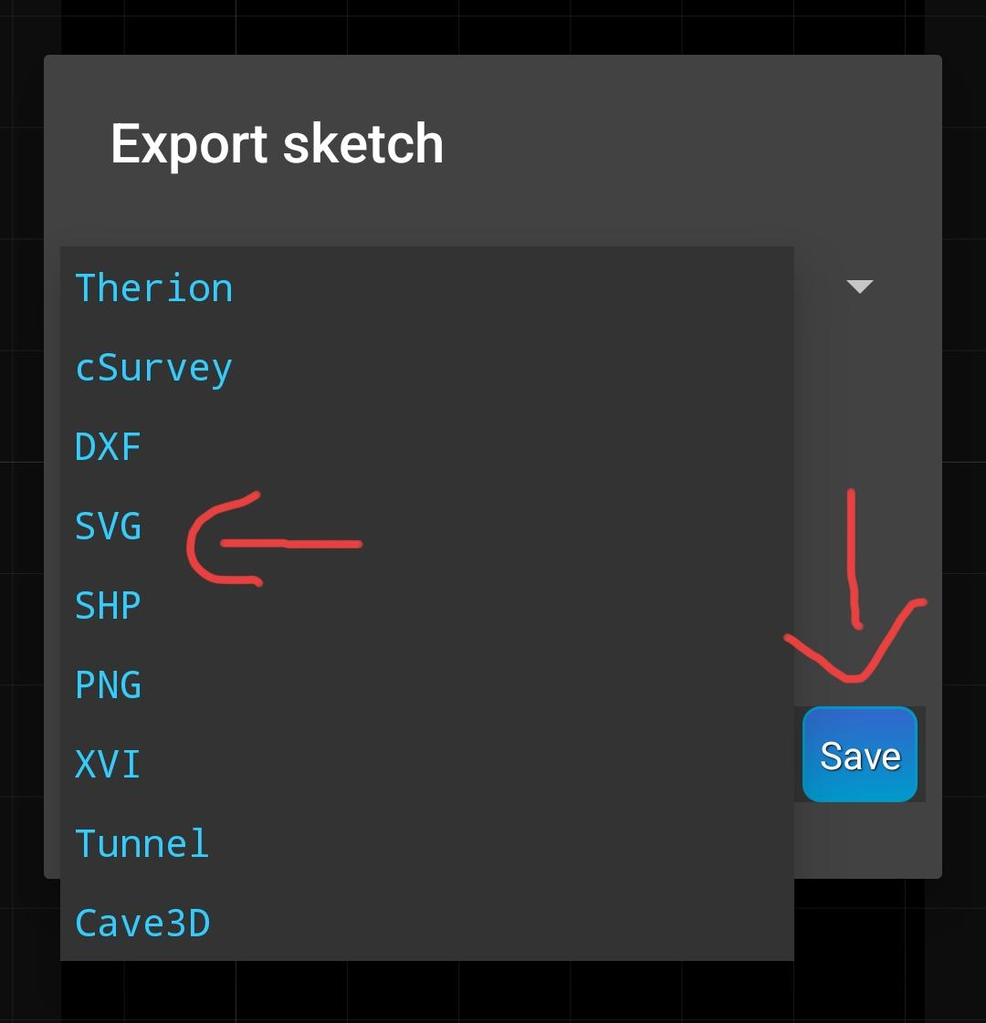

- Repeat for any remaining sketches

—-----------------

Uploading to expo

- Go to your wallet http://expo.survex.com/wallets/year/2023
- Hit choose file
- Go to phone storage -> Documents -> TopoDroid
- Go to the svx folder
- Select your .svx file and upload
- Choose file again
- Go to the svg folder
- Select your .svg files and upload

